Burger Sales SQL Queries🍔
A. KPI’S
- Total Revenue
SELECT
SUM (total_price) AS total_revenue
FROM burger_sales;
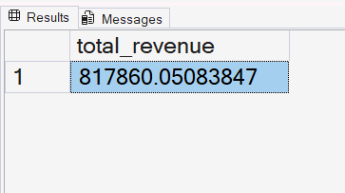
- Average Order Value
SELECT
SUM(total_price) / COUNT(DISTINCT order_id) AS Avg_Order_Value
FROM burger_sales;
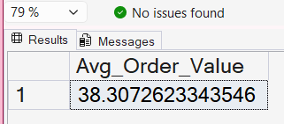
- Total Burger sold
SELECT
SUM(quantity) AS total_Burgers_sold
FROM burger_sales;
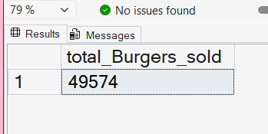
- Total Orders
SELECT
COUNT(DISTINCT order_id)AS total_orders
FROM burger_sales;
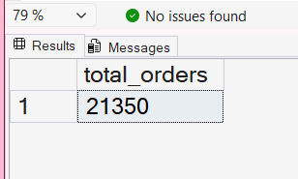

5. Average Burgers Per Order
SELECT
CAST(SUM(Quantity) AS DECIMAL (10,2)) /
CAST (COUNT (DISTINCT Order_id) AS decimal (10,2)) AS Avg_burgers_per_orders
FROM burger_sales;
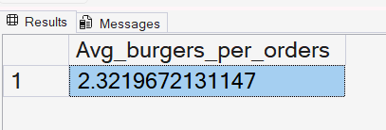
B. charts :

1. Daily Trend for Total Orders:
SELECT DATENAME (DW, order_date) as order_day, COUNT (DISTINCT order_id) AS total_orders
FROM burger_sales
GROUP BY DATENAME (DW, order_date) ;
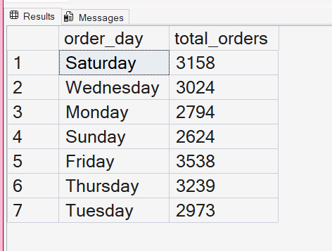

2.Hourly Trend for Total Orders
SELECT
DATEPART (HOUR, order_time) AS order_hours, COUNT (DISTINCT order_id) AS total_orders
FROM burger_sales
GROUP BY DATEPART (HOUR, order_time)
ORDER BY DATEPART(HOUR,order_time);
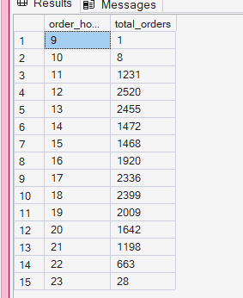

3. Percentage of sales by burger category :
SELECT
burger_category,
SUM(total_price) * 100 /
( SELECT SUM(total_price) from burger_sales WHERE MONTH(order_date)=1 ) AS Pers_for_sales
FROM burger_sales
WHERE MONTH(order_date)=1 /* month(order_date)=1 will return January months sales” */
GROUP BY burger_category;
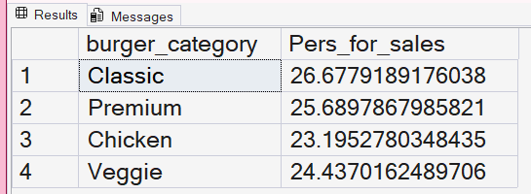

4.percentage of sales by burger size :
SELECT
burger_size,
CAST(SUM(total_price) * 100 /
( SELECT SUM(total_price) from burger_sales WHERE DATEPART(QUARTER , order_date)=1 )
AS DECIMAL (10,2))AS PCT
FROM burger_sales
WHERE DATEPART(QUARTER , order_date)=1
GROUP BY burger_size
ORDER BY PCT DESC;
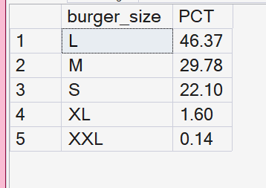

5. Total burger sold by burger category:
SELECT
burger_category,
SUM(quantity) AS Total_burger_sold
FROM burger_Sales
GROUP BY burger_category;
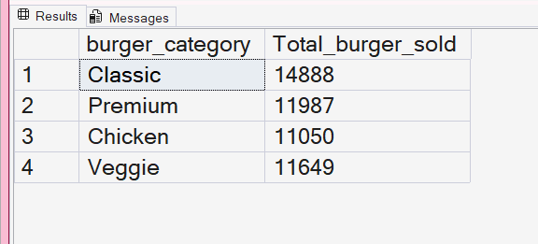
6 . Top 5 best Sellers by Total burger sold :
SELECT TOP 5
burger_name,
SUM(quantity)AS total_burgers_sold
from burger_sales
GROUP BY burger_name
ORDER BY SUM(quantity)DESC ;
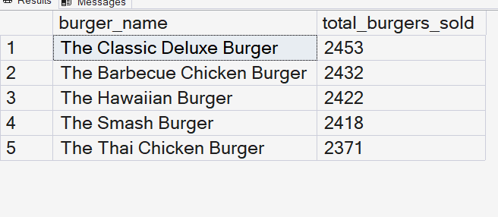
7. Bottom 5 worst sellers by total burger sold
SELECT TOP 5
burger_name,
SUM(quantity)AS total_burgers_sold
from burger_sales
GROUP BY burger_name
ORDER BY SUM(quantity) ASC ;
